Create a New Patient in MOSAIQ

# Purpose

This procedure explains how to create (register) a new MOSAIQ patient. The only time Physics does this is for QA patients. New QA patients must be created periodically due to performance issues when old patients accumulate many images. For QA patient-specific values, as well as how often each type of QA patient should be created, see spreadsheet *QA Patients*.

# Steps

1. Go to File > Register New Patient.

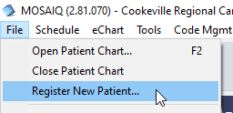

1. Fill in at least the required (red) fields on every tab.

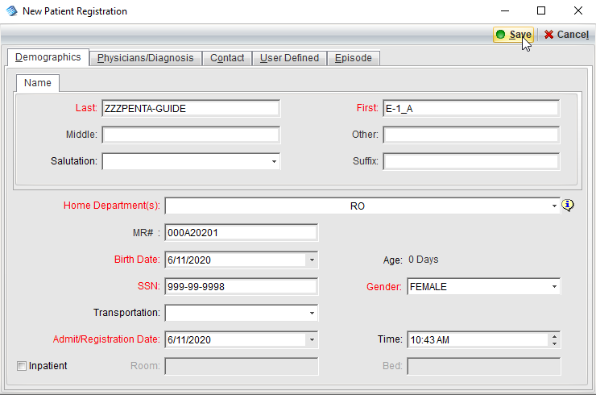

1. Click Save. If you want to enter additional patient information not offered in the New Patient Registration dialog box, click Yes. Otherwise, click No.

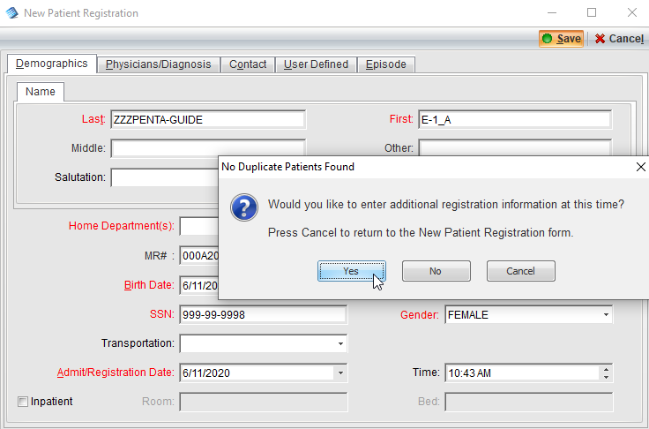

1. If this is a QA patient, add diagnosis, prescription, and fields according to *QA Patients* spreadsheet.